Titration Example Acetic Acid
50.0 mL of 0.10 M HOAC (Acetic acid) is titrated with 0.10 M NaOH Ka = 1.8 x 10⁻⁵
Initial pH Ka = x²/HA x = [H⁺] = 1.34 x 10⁻³ M pH = 2.87
After 10.0 mL of NaOH is added
R HA + OH⁻¹ H₂O (l) + A⁻¹
I 5.0 mmol 1.0 mmol 0
( 50 ml)(0.1M) 10.0 mL)(0.1M)
C – 1.0 mmol – 1.0 mmol + 1.0 mmol
E 4.0 mmol HA 0.0 1.0 mmol A⁻
pH = pKa + Log A⁻/HA = 4.74 – 0.602 = 4.14
After a total of 20.0 mL NaOH has been added
R HA + OH⁻¹ H₂O (l) + A⁻¹
I 5.0 mmol 2.0 mmol 0
( 50 ml)(0.1M) 20.0 mL)(0.1M)
C – 2.0 mmol – 2.0 mmol + 2.0 mmol
E 3.0 mmol HA 0.0 2.0 mmol A⁻

pH = pKa + log A⁻/HA = 4.74 – 0.176 = 4.56
after 25 ml of the base has been added
R HA + OH⁻¹ H₂O (l) + A⁻¹
I 5.0 mmol 2.5 mmol 0
( 50 ml)(0.1M) 25.0 mL)(0.1M)
C – 2.5 mmol – 2.5 mmol + 2.5 mmol
E 2.5 mmol HA 0.0 2.5 mmol A⁻
Notice that the moles of HA and A⁻ are the same, and that half of the acid has been reacted. This point is known as the halfway point and there is an important implication here
pH = pKa + Log A⁻/H = 4.74 + Log 1 = 4.74
at the ½ way point pH = pKa No matter how I reach that point.

After 49 mL of base is added
R HA + OH⁻¹ H₂O (l) + A⁻¹
I 5.0 mmol 4.9 mmol 0
( 50 ml)(0.1M) 49.0 mL)(0.1M)
C – 4.9 mmol – 4.9 mmol + 4.9 mmol
E 0.1 mmol HA 0.0 4.9 mmol A⁻
pH = pKa = Log A⁻/HA = 4.74 + log 4.9/0.1 = 4.74 + 1.69 = 6.43

After adding 51 ml of base
R HA + OH⁻¹ H₂O (l) + A⁻¹
I 5.0 mmol 5.1 mmol 0
( 50 ml)(0.1M) 51.0 mL)(0.1M)
C – 5.0 mmol – 5.0 mmol + 1.0 mmol
E 0 mmol HA 0.10 mmol 5.0 mmol A⁻
This solution now has two bases, OH⁻¹ and A⁻ (C₂H₃O₂⁻¹). OH⁻ is a strong base and Acetate is a weak base. The OH⁻¹ will dictate the final pH. Here the concentration of OH⁻¹ = 0.10 mmol/101 mL = 9.990 x 10⁻⁴ M OH⁻¹ pOH = 3.00 and pH = 11.00
So in a difference of 2.0 mL of added base, we jump from pH 6.43 to a pH of 11.0
pH at 49.99 and 50.01 7.43 and 10.00 In 0.2 mL
This is why a few extra drops of added base took your titrations from clear to magenta.

At the Equivalence point things will change and the calculation becomes slightly more complicated. The equivalence point is when the moles of Acid HA and Strong base OH⁻¹ are equal. Here it would be when 50.0 mL of the OH⁻ has been added
R HA + OH⁻¹ H₂O (l) + A⁻¹
I 5.0 mmol 5.0 mmol 0
( 50 ml)(0.1M) 50.0 mL)(0.1M)
C – 5.0 mmol – 5.0 mmol + 1.0 mmol
E 0 mmol HA 0.0 mmol 5.0 mmol A⁻
The only acidic or basic species is A⁻¹ or acetate in this case.
A⁻¹ is the conjugate BASE of our weak acid.
(Ka for the acid) x (K_{B} for the base) = K_{w}
K_{B} for acetate = 1 x 10⁻¹⁴/1.8 x 10⁻⁵ = 5.56 x 10⁻¹⁰ and the reaction for this weak base with water is
C₂H₃O₂⁻¹ + H₂O HC₂H₃O₂ + OH⁻ This is called the hydrolysis of the weak base
C₂H₃O₂⁻¹ + H₂O HC₂H₃O₂ + OH⁻ K_{B} = [OH⁻][HC₂H₃O₂]
[C₂H₃O₂⁻¹]
Here the HH equation will not work as you’d get log of 5.00/0 which is undefined. You must solve using this algebra above:
C₂H₃O₂⁻¹ + H₂O HC₂H₃O₂ + OH⁻
5.0 mmol 0 0
– x + x + x
5 – x x x
Concentration of acetate = 5 mmol/100 milliliters = = 0.05 M
K_{B} = [OH⁻][HC₂H₃O₂]
[C₂H₃O₂⁻¹]
K_{B} = x²/[0.05 – x] x << 0.05 so neglect x
K_{b}[0.05] = x² = [(5.56 x 10⁻¹⁰)(0.05)]^{1/2} = 5.273 x 10⁻⁶ = x this is much much less than 0.05 pOH of this would be 5.27 and pH would be 8.72
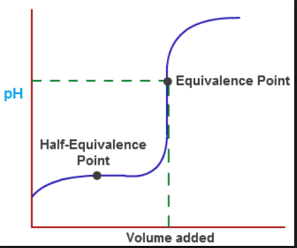
Important points to recognize/remember:
The half way point pH = pKa
The equivalence point pH will be HIGHER than 7.0 for all weak acids
After the endpoint the pH will get higher quickly
Notice that the pH changes RAPIDLY (in just a few milliliters) near the endpoint.

For a weak base titrated with a strong acid the curve would be inverted, but the same three points would be significant
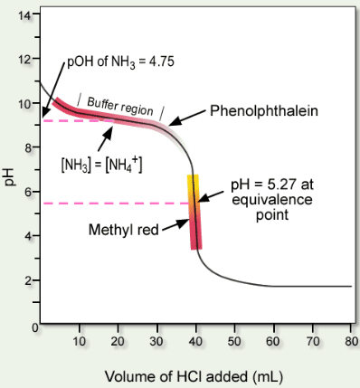
At the halfway point [B] = [BH⁺] pOH = pK_{b}
Equivalence point the conjugate acid [BH⁺] dictates pH
After equivalence point pH drops quickly

