Graphs and Motion Maps of Accelerated Objects
Increasing speed in the positive direction
Think about the cart as it rolls down the incline starting from rest
Draw a motion map. Include velocity and acceleration vectors

________________________________________________________________________________________>

Is the velocity positive or negative? Is the acceleration positive or negative?
Predict the graphs describing the motion  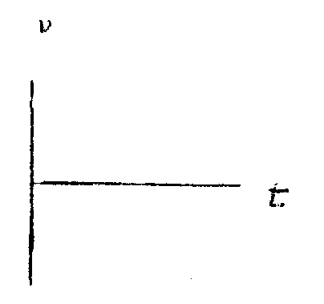 | The slope of the position vs time graph is  (constant/ increasing/ decreasing) and  (positive/ negative)  and represents __________________  The slope of the velocity vs time graph is  (constant/ increasing/ decreasing) and  (positive/ negative)  and represents __________________

Decreasing speed in the positive direction
Think about the cart as it rolls up the incline after a push
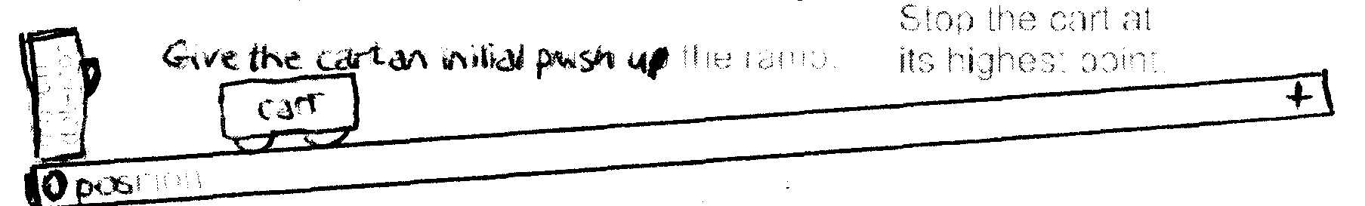
Only consider the motion up thee ramp until the cart stops
Draw a motion map. Include velocity and acceleration vectors

________________________________________________________________________________________>

Is the velocity positive or negative? Is the acceleration positive or negative?
Predict the graphs describing the motion | The slope of the position vs time graph is  (constant/ increasing/ decreasing) and  (positive/ negative)  and represents __________________  The slope of the velocity vs time graph is  (constant/ increasing/ decreasing) and  (positive/ negative)  and represents __________________

Increasing speed in the negative direction
Think about the cart as it rolls down the incline toward the origin
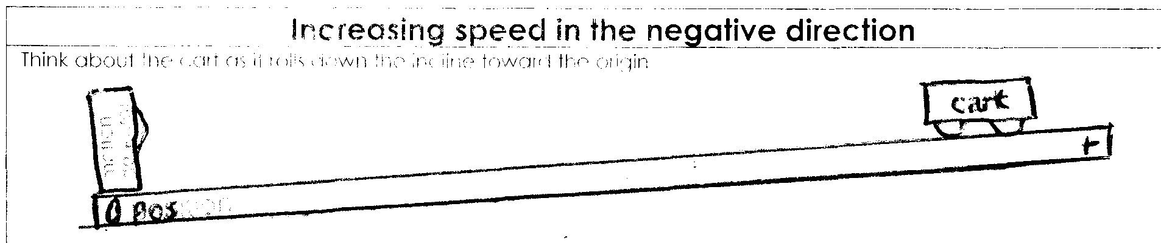

Draw a motion map. Include velocity and acceleration vectors

________________________________________________________________________________________>

Is the velocity positive or negative? Is the acceleration positive or negative?
Predict the graphs describing the motion | The slope of the position vs time graph is  (constant/ increasing/ decreasing) and  (positive/ negative)  and represents __________________  The slope of the velocity vs time graph is  (constant/ increasing/ decreasing) and  (positive/ negative)  and represents __________________

Decreasing speed in the negative direction
Think about the cart as it rolls down the incline toward the origin
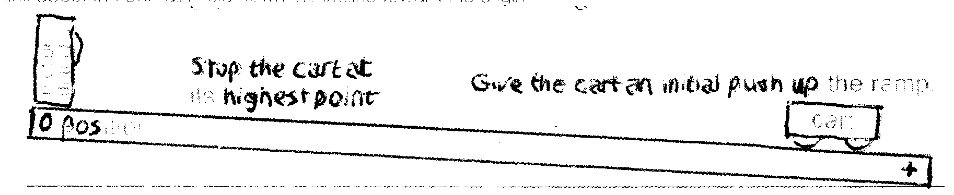

Draw a motion map. Include velocity and acceleration vectors

________________________________________________________________________________________>

Is the velocity positive or negative? Is the acceleration positive or negative?
Predict the graphs describing the motion | The slope of the position vs time graph is  (constant/ increasing/ decreasing) and  (positive/ negative)  and represents __________________  The slope of the velocity vs time graph is  (constant/ increasing/ decreasing) and  (positive/ negative)  and represents __________________

Up and Down the ramp
Think about the cart as it rolls down the incline toward the origin
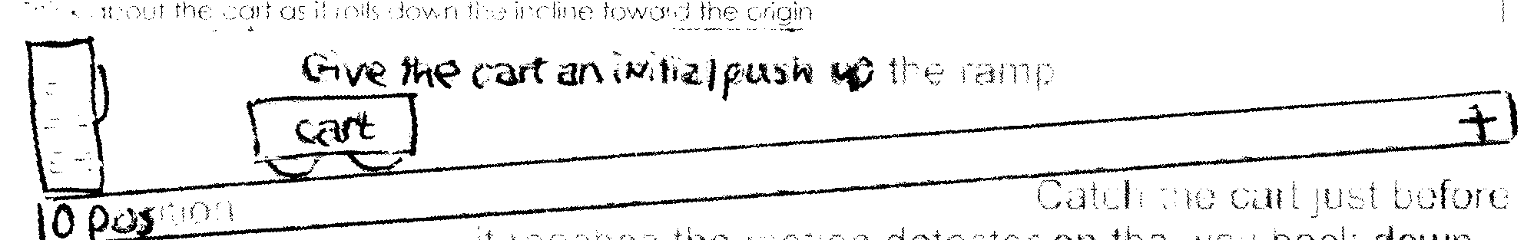

Draw a motion map. Include velocity and acceleration vectors

________________________________________________________________________________________>

Is the velocity positive or negative? Is the acceleration positive or negative?
Predict the graphs describing the motion | The slope of the position vs time graph is  (constant/ increasing/ decreasing) and  (positive/ negative)  and represents __________________  The slope of the velocity vs time graph is  (constant/ increasing/ decreasing) and  (positive/ negative)  and represents __________________

Up and Down the ramp passing the origin twice
Think about the cart as it rolls down the incline toward the origin
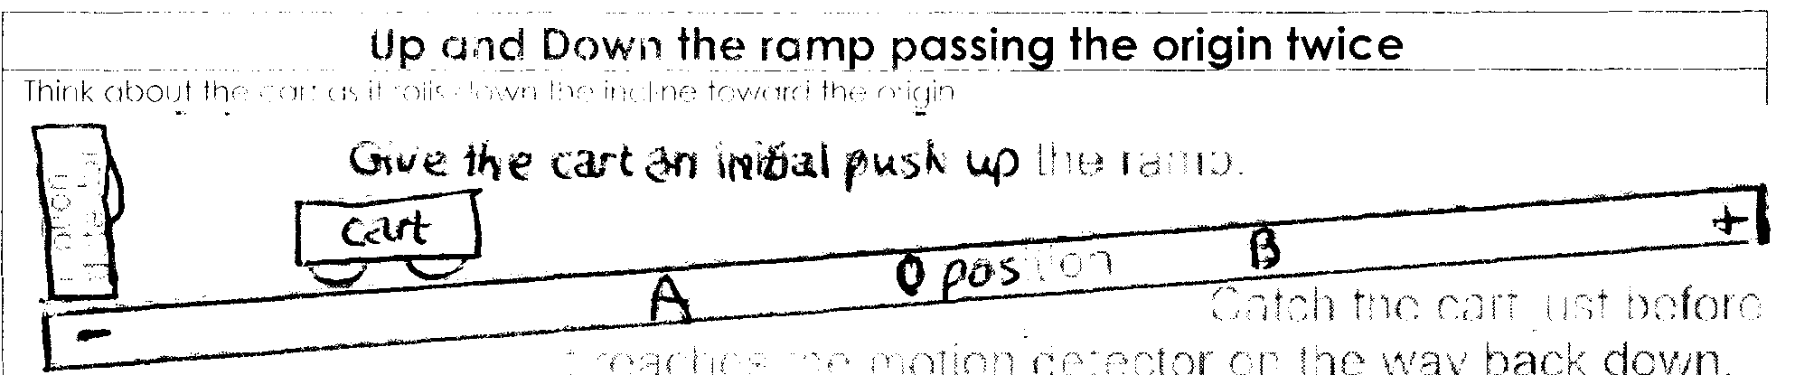

Draw a motion map. Include velocity and acceleration vectors

________________________________________________________________________________________>

Is the velocity positive or negative? Is the acceleration positive or negative?
Predict the graphs describing the motion | The slope of the position vs time graph is  (constant/ increasing/ decreasing) and  (positive/ negative)  and represents __________________  The slope of the velocity vs time graph is  (constant/ increasing/ decreasing) and  (positive/ negative)  and represents __________________

