2002 M #2
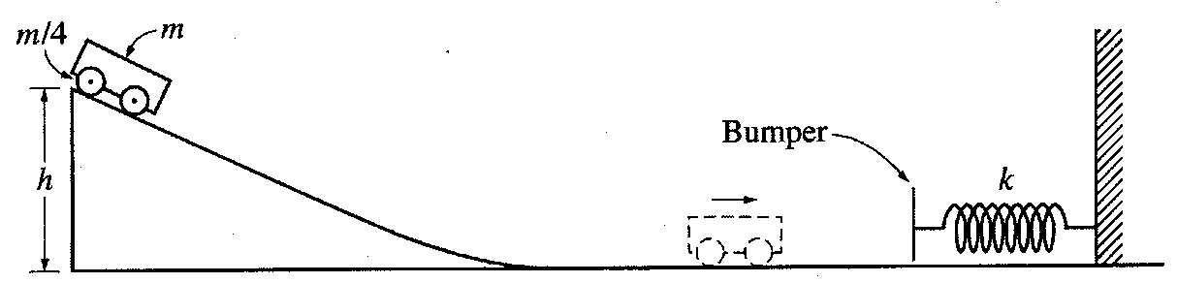
2002M2. The cart shown above is made of a block of mass m and four solid rubber tires each of mass m/4 and radius r. Each tire may be considered to be a disk. (A disk has rotational inertia ½ ML², where M is the mass and L is the radius of the disk.) The cart is released from rest and rolls without slipping from the top of an inclined plane of height h. Express all algebraic answers in terms of the given quantities and fundamental constants.
a. Determine the total rotational inertia of all four tires.
b. Determine the speed of the cart when it reaches the bottom of the incline.
c. After rolling down the incline and across the horizontal surface, the cart collides with a bumper of negligible mass attached to an ideal spring, which has a spring constant k. Determine the distance x_{m} the spring is compressed before the cart and bumper come to rest.
d. Now assume that the bumper has a non-negligible mass. After the collision with the bumper, the spring is compressed to a maximum distance of about 90% of the value of x_{m} in part (c). Give a reasonable explanation for this decrease.

